 -EN-

GASOLINE WATER PUMP

HY50-A / HY80-A

ORIGINAL INSTRUCTIONS

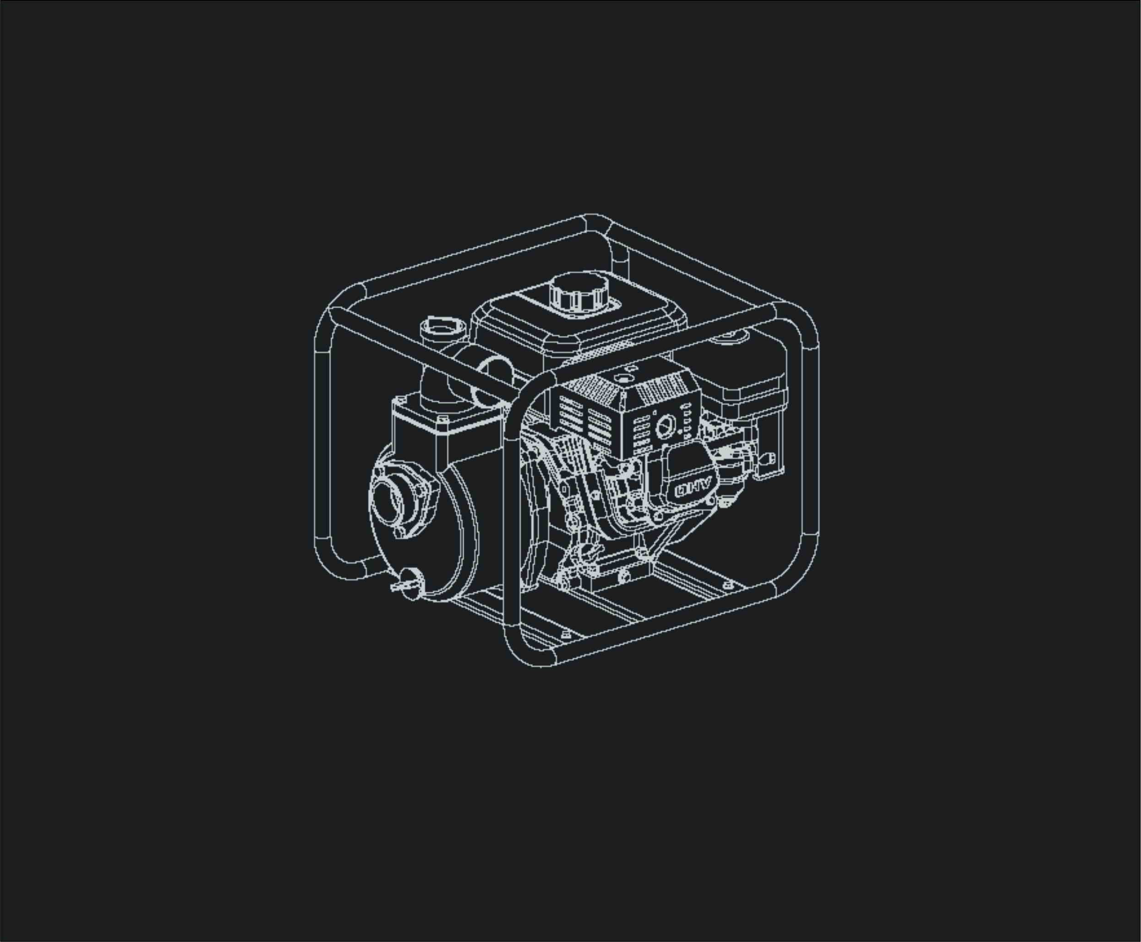

**SAFETY INFORMATION**

Read and understand this owner's manual before operating your water pump. You can help prevent accidents by being familiar with your water pump’s controls, and by observing safe operating procedures.

**Operator Responsibility**

● Know how to stop the engine quickly in case of emergency.

● Understand the use of all water pump controls.

● Do not let children operate the water pump without parental supervision. Keep children and pets away from the area of operation.

●This pump CAN NOT be used for dirty water and sea water.

**Refuel With Care**

Gasoline is extremely flammable, and gasoline vapor can explode. Refuel outdoors, in a well-ventilated area, with the engine stopped. Never smoke near gasoline, and keep other flames and sparks away.

**Hot Exhaust**

● The muffler becomes very hot during operation and remains hot for a while after stopping the engine. Be careful not to touch the muffler while it is hot. Let the water pump cool before storing it indoors.

● To prevent fire hazards, keep the water pump at least 3 feet (1meter) away from building walls and other equipment during operation.

**Carbon Monoxide Hazards**

● Exhaust contains poisonous carbon monoxide, a colorless and odorless gas. Breathing exhaust directly can cause loss of consciousness and may lead to death.

● If you run the water pump in an area that is confined, the air you breathe could contain a dangerous amount of exhaust gas. To keep exhaust gas from accumulating, provide adequate ventilation.

**CONTROLS & FEATURES**

COMPONENT & CONTROL LOCATION

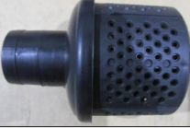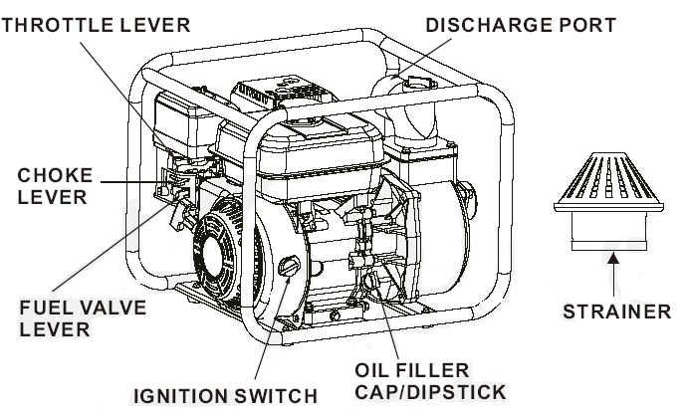

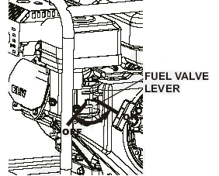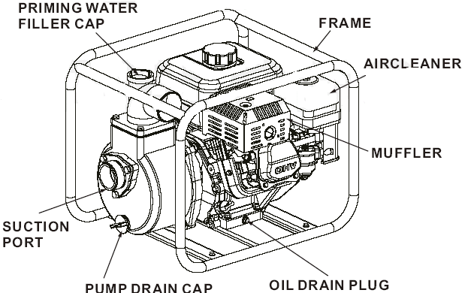

**CONTROLS**

**Fuel Valve Lever**

The fuel valve opens and closes the passage between the fuel tank and the carburetor.

The fuel valve lever must be in the **ON** position for the engine to run.

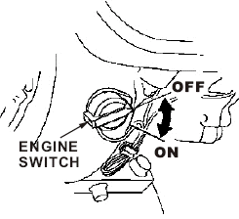When the engine is not in use, leave the fuel valve lever in the **OFF** position to prevent carburetor flooding and to reduce the possibility of fuel leakage.

**Engine Switch**

The engine switch enables and disables the ignition system.

The engine switch must be in the **ON** position for the engine to run.

Turning the engine switch to the **OFF** position stops the engine.

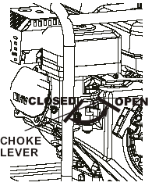**Choke Lever**

The choke lever opens and closes the choke valve in the carburetor.

The **CLOSED** position enriches the fuel mixture for starting a cold engine.

The **OPEN** position provides the correct fuel mixture for operation after starting, and for restarting a warm engine.

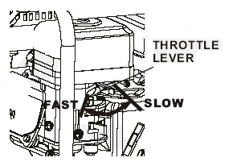**Throttle Lever**

The throttle lever controls engine speed.

Moving the throttle lever in the directions shown makes the engine run faster or slower.

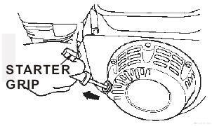**Recoil Starter Grip**

Pulling the starter grip operates the recoil starter to crank the engine.

**FEATURES**

**Oil Alert System**

The Oil Alert system is designed to prevent engine damage caused by an insufficient amount of oil in the crankcase.

Before the oil level in the crankcase can fall below a safe limit, the Oil Alert system will automatically stop the water pump.

**BEFORE OPERATION CHECKS**

**Check the Suction and Discharge Hoses**

● Remember that the suction hose must be reinforced construction to prevent hose collapse.

● Check that the sealing washer in the suction hose connector is in good condition.

●Check that the hose connectors and clamps are securely installed.

● Check that the strainer is in good condition and is installed on the suction hose.

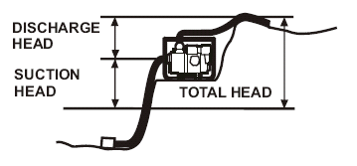**Check the Engine**

● Check the oil lever.

● Check the air filter.

● Check the fuel level.

**OPERATION**

**PUMP PLACEMENT**

For best pump performance, place the pump near the water level, and use hose that are no longer than necessary. That will enable the pump to produce the greatest output with the least self-priming time.

As head (pumping height) increases, pump output decrease. The length, type, and size of the suction and discharge hoses can also significantly affect pump output.

Minimizing suction head (placing the pump near the water lever) is also very important for reducing self-priming time. Self-priming time is the time it takes the pump to bring water the distance of the suction head during initial operation.

**SUCTION HOSE INSTALLATION**

Do not use a hose smaller than the pump's suction port size.

Pump performance is best when the pump is near the water level, and the hoses are short.

Minimum hose size: 50 mm

Use a hose clamp to securely fasten the hose connector to the suction hose in order to prevent air leakage and loss of suction. Verify that the hose connector sealing washer is in good condition.

Install the strainer on the other end of the suction hose, and secure it with a hose clamp. The strainer will help to prevent the pump from becoming clogged or damaged by debris.

Securely tighten the hose connector on the pump suction port.

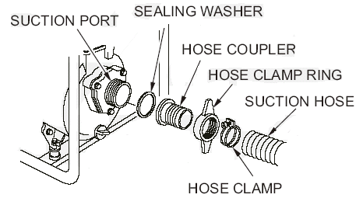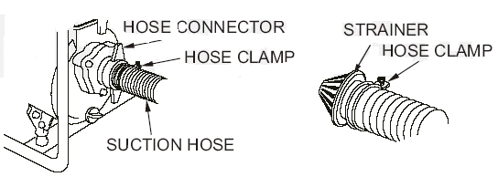

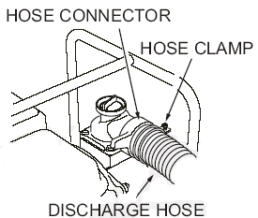**DISCHARGE HOSE INSTALLATION**

It is best to use a short, large-diameter hose, because that will reduce fluid friction and improve pump output.

Tighten the hose clamp securely to prevent the discharge hose from disconnecting under pressure.

**PRIMING THE PUMP**

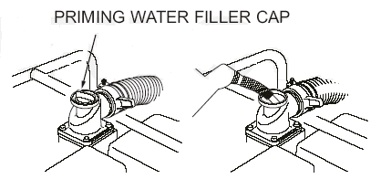Before starting the engine, remove the filler cap from the pump chamber, and completely fill the pump chamber with water. Reinstall the filler cap, and tighten it securely.

NOTICE

Operating the pump dry will destroy the pump seal. If the pump has been operated dry, stop the engine immediately, and allow the pump to cool before priming.

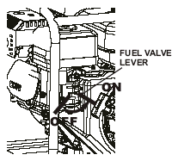

**STARTING THE ENGINE**

1. Prime the pump.

2. Move the fuel valve lever to the **ON** position.

3. To start a cold engine, move the choke lever to the **CLOSED** position.

To restart a warm engine, leave the choke lever in the **OPEN** position.

4. Move the throttle lever from the SLOW position about 1/3 of the way toward the **FAST** position.



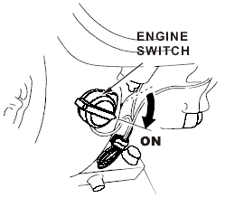5. Turn the engine switch to the **ON** position.

6. Operate the starter.

Pull the starter grip lightly until you feel resistance, then pull briskly.

Return the starter grip gently. 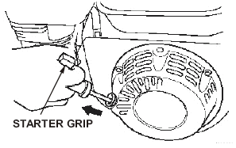

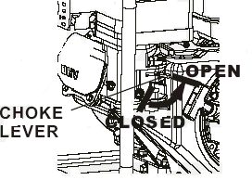7. If the choke lever has been moved to the **CLOSED** position to start the engine, gradually move it to the **OPEN** position as the engine warms up.

**STOPPING THE ENGINE**

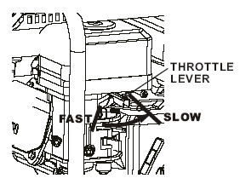To stop the engine in an emergency, simply turn the engine switch to the **OFF** position.

Under normal conditions, use the following procedure.

1. Move the throttle lever to the **SLOW** position.

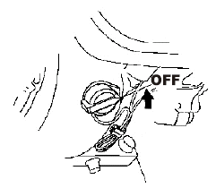2. Turn the engine switch to the **OFF** position.

3. Turn the fuel valve lever to the **OFF** position.

**SETTING ENGINE SPEED**

Position the throttle lever for the desired engine speed.

For engine speed recommendations, refer to the instructions provided with the equipment powered by this engine.

**SERVICING YOUR PUMP**

If you operate your water pump under severe conditions, such as sustained high-load or high-temperature operation, or use in unusually wet or dusty conditions, consult your technician for recommendations applicable to your individual needs and use.

To ensure the best quality and reliability, use only new, genuine parts or their equivalents for repair and replacement.

**SAFETY PRECAUTIONS**

Make sure the engine is off before you begin any maintenance or repair.

This will eliminate several potential hazards:

● Carbon monoxide poisoning from engine exhaust.

Be sure there is adequate ventilation whenever you operate the water pump.

● Burns from hot parts.

Let the water pump cool before touching.

● Injury from moving parts.

Do not run the water pump unless instructed to do so.

Read the instructions before you begin, and make sure you have the tools and skills required.

To reduce the possibility of fire or explosion, be careful when working around gasoline. Use only a nonflammable solvent, not gasoline, to clean parts. Keep cigarettes, sparks and flames away from all fuel related parts.

Remember that a technician knows your water pump best and is fully equipped to maintain and repair it.

MAINTENANCE SCHEDULE

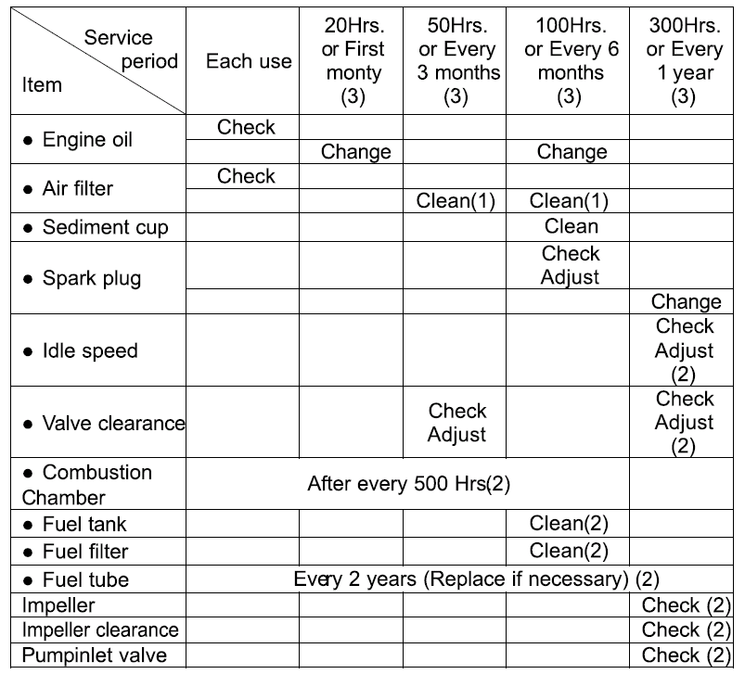

● Emission related items.

(1) Service more frequently when used in dusty areas.

(2) These items should be serviced by an technician.

(3) For commercial use, log hours of operation to determine proper maintenance intervals.

**REFUELING**

Use unleaded gasoline with a pump octane rating of 86 or higher.

Unleaded gasoline produces fewer engine and spark plug deposits and extends exhaust system life.

***WARNING ！***

***Gasoline is highly flammable and explosive, and you can be burned or seriously injured when refueling.***

***● Stop engine and keep heat, sparks, and flame away.***

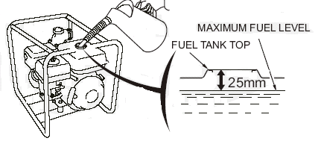***● Refuel only outdoors.***

***● Wipe up spills immediately.***

**Adding Fuel**

1. Remove the fuel tank cap.

2. Add fuel to the bottom of the fuel level limit in the neck of the fuel tank.

Do not overfill. Wipe up spilled fuel before starting the water pump.

**ENGINE OIL LEVEL CHECK**

Check the engine oil level with the engine stopped and in a level position.

1. Remove the filler cap/dipstick and wipe it clean.

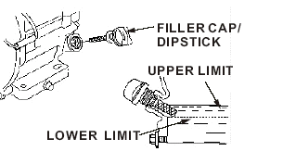2. Insert and remove the dipstick with out screwing it into the filler neck.

Check the oil level shown on the dipstick.

3. If the oil level is low, fill to the edge of the oil filler hole with the recommended oil.

4. Screw in the filler cap/dipstick securely.

**ENGINE OIL CHANGE**

Drain the used oil while the engine is warm. Warm oil drains quickly and completely.

***Warning! Pay attention that the engine oil may be very hot if it is drained off directly after the engine is shut off, or allow the engine to cool a few minutes before draining the oil.***

1. Place a suitable container below the engine to catch the used oil, then remove the filler cap/dipstick, drain plug, and washer.

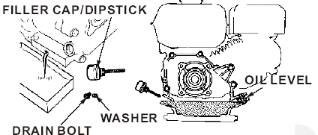2. Allow the used oil to drain completely, then reinstall the drain plug, washer, and tighten drain plug securely.

3. With the engine in a level position, fill to the outer edge of the oil filler hole with the recommended oil .

4. Screw in the filler cap/dipstick securely.

**ENGINE OIL RECOMMENDATIONS**

Oil is a major factor affecting performance and service life. Use 4-stroke

automotive detergent oil.SAE 10W-30 is recommended for general use.

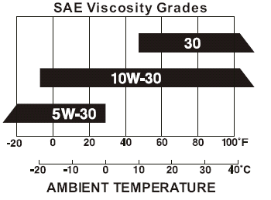***Warning! We suggest you take used oil in a sealed container to your local recycling center or service station for reclamation. Do not throw it in the trash, pour it on the ground, or down a drain as the oil or gasoline concerning the toxicity.***

**AIR CLEANER SERVICE**

A dirty air filter will restrict air flow to the carburetor, reducing engine performance. If you operate the engine in very dusty areas, clean the air filter more often than specified in the MAINTENANCE SCHEDULE.

***NOTICE***

***Operating the engine without an air filter, or with a damaged air filter,***

***will allow dirt to enter the engine, causing rapid engine wear.***

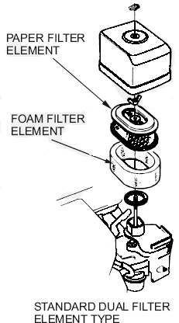**Dual Filter Element Types**

1. Remove the wing nut from the air cleaner cover, and remove the cover.

2. Remove the wing nut from the air filter, and remove the filter.

3. Remove the foam filter from the paper filter.

4. Inspect both air filter elements, and replace them if they are damaged.

5. Clean the air filter elements if they are to be reused.

Paper air filter element: Tap the filter element several times on a hard surface to remove dirt.

Never try to brush off dirt; brushing will force dirt into the fibers.

Foam air filter element: Clean in warm soapy water, rinse, and allow to dry thoroughly.

Dip the filter element in clean engine oil, then squeeze out all excess oil.

6. Wipe dirt from the inside of the air cleaner base and cover, using a moist rag.

7. Place the foam air filter element over the paper element, and reinstall the assembled air filter. Be sure the gasket is in place beneath the air filter. Tighten the air filter wing nut securely.

8. Install the air cleaner cover, and tighten the cover wing nut securely.

**SEDIMENT CUP CLEANING**

1. Move the fuel valve to the **OFF** position, then remove the fuel sediment cup and O-ring.

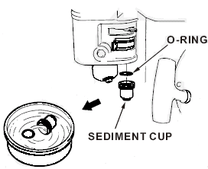2. Wash the sediment cup and O-ring in nonflammable solvent, and dry them thoroughly.

3. Place the O-ring in fuel valve, and install the sediment cup. Tighten the sediment securely.

4. Move the fuel valve to the **ON** position, and check for leaks. Replace the O-ring if there is any leakage.

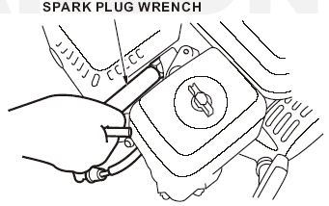**SPARK PLUG SERVICE**

Recommended spark plug: F6RTC

1. Disconnect the spark plug cap, and remove any dirt from around the spark plug area.

2. Remove the spark plug with a spark plug wrench.

3. Inspect the spark plug. Replace it if the electrodes are worn, or if the insulator is cracked or chipped.

4. Measure the spark plug electrode gap with a suitable gauge. The gap should be 0.028~0.031 in (0.70~0.80mm). Correct the gap if necessary, by carefully bending the side electrode.

5. Install the spark plug carefully, by hand, to avoid cross-threading.

6. After the spark plug seats, tighten with a spark plug wrench to compress the sealing washer.

If reinstalling the used spark plug, tighten 1/8-1/4 turn after the spark plug seats.

If installing a new spark plug, tighten 1 / 2 turn after the spark plug seats.

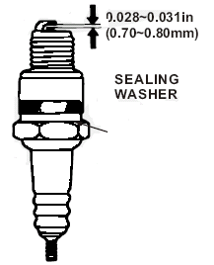***NOTICE***

***A loose spark plug can overhand and damage the engine.***

***Overtightening the spark plug can damage the threads in the cylinder head.***

7. Attach the spark plug cap.

**STORING YOUR WATER PUMP**

**Storage Preparation**

Proper storage preparation is essential for keeping your water pump troublefree and looking good.

**Cleaning**

If the water pump has been running, allow it to cool for at least half an hour before cleaning. Clean all exterior surfaces, touch up any damaged paint, and coat other areas that may rust with a light film of oil.

**Fuel**

Gasoline will oxidize and deteriorate in storage. Old gasoline will cause hard starting, and it leaves gum deposits that clog the fuel system.

If the gasoline in your water pump deteriorates during storage, you may need to have the carburetor and other fuel system components serviced or replaced.

You can extend fuel storage life by adding a fuel stabilizer, or you can avoid fuel deterioration problems by draining the fuel tank and carburetor.

**ADDING A FUEL STABILIZER TO EXTEND FUEL STORAGE LIFE**

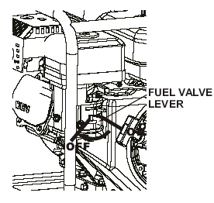When adding a fuel stabilizer, fill the fuel tank fresh gasoline.

1. Add fuel stabilizer following the manufacturer's instructions.

2. After adding a fuel stabilizer, run the water pump outdoors for 10 minutes to be sure that treated gasoline has replace the untreated gasoline in the carburetor.

3. Stop the engine, and move the fuel valve to the **OFF** position.

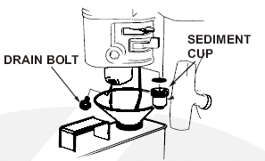**DRAINING THE FUEL AND CARBURETOR**

1. Place an approved gasoline container below the carburetor, and use a funnel to avoid spilling fuel.

2. Remove the carburetor drain bolt and sediment cup, then move the fuel valve lever to the ON position.

**ENGINE OIL**

1. Change the engine oil.

2. Remove the spark plugs.

3. Pour a tablespoon (5~10cc) of clean engine oil into the cylinder.

4. Pull the starter rope several times to distribute the oil in the cylinder.

5. Reinstall the spark plug.

6. Pull the starter rope slowly until resistance is felt. This will close the valves so moisture cannot enter the engine cylinder. Return the starter rope gently.

**Storage Precautions**

Select a well ventilated storage area away from any appliance that operates with a flame, such as a furnace, water heater, or clothes dryer.

Also avoid any area with a spark-producing electric motor, or where power tools are operated.

If possible, avoid storage areas with high humidity, because that promotes rust and corrosion.

Unless all fuel has been drained from the fuel tank, leave the fuel valve lever in the OFF position to reduce the possibility of fuel leakage.

With the engine cool, cover the engine to keep out dust.

Do not use sheet plastic as a dust cover. A nonporous cover will trap moisture around the engine, promoting rust and corrosion.

**Removal From Storage**

Check your engine as described in the BEFORE OPERATION chapter of this manual.

If the fuel was drained during storage preparation, fill the tank with fresh gasoline. Gasoline oxidizes and deteriorates over time, causing hard starting.

**TRANSPORTING**

This machine must be kept in a equilibrium position, can not be side turn during the transport

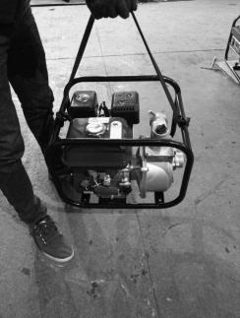**勾勾**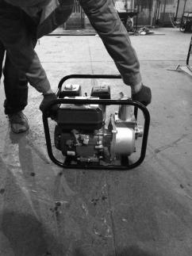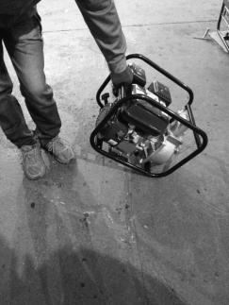

**In the figure below, the center of gravity of the machine is suitable for the lifting position of the machine.**

If the engine has been running, allow it to cool for at least 15 minutes before loading the engine-powerd equipment on the transport vehicle. A hot engine and exhaust system can burn you and can ignite some materials.

Keep the engine level when transporting to reduce the possibility of fuel leakage. Move the fuel valve lever to the **OFF** position.

**TAKING CARE OF UNEXPECTED PROBLEMS**

**ENGINE WILL NOT START**

|  |  |  |
| --- | --- | --- |
| ENGINE WILL NOT START | Possible Cause | Correction |
| 1. Check control positions. | Fuel valve OFF. | Move lever to ON. |
|  | Choke OFF. | Move the choke / throttle lever to CHOKE ON position unless engine is warm. |
|  | Ignition switch OFF. | Move the throttle lever to  FAST position. |
| 2. Check fuel. | Out of fuel. | Refuel |
|  | Bad fuel; engine stored without treating or draining gasoline, of refueled with bad gasoline. | Drain the fuel tank and  carburetor. Refuel with fresh gasoline. |
| 3. Remove and inspect spark plug. | Spark plug faulty, fouled, or improperly gapped. | Replace the spark plug. |
|  | Spark plug wet with fuel  (flooded engine). | Dry and reinstall spark plug. Start engine with choke / throttle lever in FAST position. |
| 4. Take engine to a technician. | Fuel filter clogged, carburetor malfunction, ignition malfunction,  valves stuck, etc. | Replace or repair faulty  components as necessary. |

**ENGINE LACKS POWER**

|  |  |  |
| --- | --- | --- |
| ENGINE LACKS POWER | Possible Cause | Correction |
| 1. Check air cleaner. | Air cleaner elements clogged. | Clean or replace air cleaner elements. |
| 2. Check fuel. | Bad fuel; engine stored without treating or draining gasoline, of refueled with bad gasoline. | Drain the fuel tank and carburetor. Refuel with fresh gasoline. |
| 3. Take engine to a technician. | Fuel filter clogged, carburetor malfunction, ignition malfunction, valves stuck, etc. | Replace or repair faulty components as necessary. |

**NO PUMP OUTPUT**

|  |  |  |
| --- | --- | --- |
| NO PUMP OUTPUT | Possible Cause | Correction |
| 1. Check pump chamber. | Pump not primed. | Prime pump. |
| 2. Check suction hose. | Hose collapsed, cut or punctured. | Replace suction hose. |
|  | Strainer not completely underwater. | Sink the strainer and the end of a suction hose completely underwater. |
|  | Air leak at connector. | Replace sealing washer if missing or damaged. Tighten hose connector and clamp. |
|  | Strainer clogged. | Clean debris from strainer. |
| 3. Measure suction and discharge  head. | Excessive head. | Relocate pump and / or hoses to reduce head. |
| Check engine. | Engine lacks power. | See page 21. |

**LOW PUMP OUTPUT**

|  |  |  |
| --- | --- | --- |
| LOW PUMP OUTPUT | Possible Cause | Correction |
| 1. Check suction hose. | Hose collapsed, damaged, too long, or diameter too small. | Replace suction hose. |
|  | Air leak at connector. | Replace sealing washer if missing or damaged.  Tighten hose connector and clamp. |
|  | Strainer clogged. | Clean debris from strainer. |
| 2. Check discharge hose. | Hose damaged, too long, or diameter too small | Replace discharge hose. |
| 3. Measure suction and discharge head. | Marginal head. | Relocate pump and / or hoses to reduce head. |
| 4. Check engine. | Engine lacks power. | See page 21. |

**SPECIFICATIONS**

**Engine design and performance (HY50-A)**

|  |  |
| --- | --- |
| Model | PT170F |
| Engine type | 4-stroke, OHV, single cylinder |
| Displacement | 212 cc |
| Bore×stroke | 70× 55 mm |
| Fuel tank capacity | 3.6l |
| Rated output | 3.2kW/3600/min |
| Engine oil capacity | 0.6l |
| Fuel consumption | 395g/kW.h |
| Cooling system | Forced air cooling |
| Ignition system | Transistorized magneto |
| PTO shaft rotation | Counterclockwise |

**Pump**  **(HY50-A)**

|  |  |
| --- | --- |
| Max. Head | 30m |
| Suction head | 7m |
| Flow | 33m3/h |
| Diameter of suction pipe | 50mm |
| Diameter of discharge pipe | 50mm |
| Engine type | PT170F |
| Rated output power | 3.2kW/3600/min |
| Net weight | 22kg |
| Max. Permissible pressure | 0.25MPa |
| Measured sound pressure level | 88.7dB(A) |
| Measured sound power level | 101.6dB(A), K=4.42 dB(A) |
| Guaranteed sound power level | 106dB(A) |

**Engine design and performance (HY80-A)**

|  |  |
| --- | --- |
| Model | PT170F |
| Engine type | 4-stroke, OHV, single cylinder |
| Displacement | 212 cc |
| Bore×stroke | 70× 55 mm |
| Fuel tank capacity | 3.6l |
| Rated output | 3.65kW/3600/min |
| Engine oil capacity | 0.6l |
| Fuel consumption | 395g/kW.h |
| Cooling system | Forced air cooling |
| Ignition system | Transistorized magneto |
| PTO shaft rotation | Counterclockwise |

**Pump**  **(HY80-A)**

|  |  |
| --- | --- |
| Max. Head | 28m |
| Suction head | 7m |
| Flow | 60m3/h |
| Diameter of suction pipe | 80mm |
| Diameter of discharge pipe | 80mm |
| Engine type | PT170F |
| Rated output power | 3.65kW/3600/min |
| Net weight | 24kg |
| Max. Permissible pressure | 0,25 MPa |
| Measured sound pressure level | 91 dB(A) |
| Measured sound power level | 104,8 dB(A) k=2.32dB(A) |
| Guaranteed sound power level | 106 dB(A) |

**Safety label**

Explanation of warning labels

 Read the instruction manual before using the machine

 Keep bystanders away

 Caution! Do not use the machine indoor.

 Risk of high temperature

 Do not touch the high temperature

 No naked flames

 hearing protection must be worn

Piping diagrams

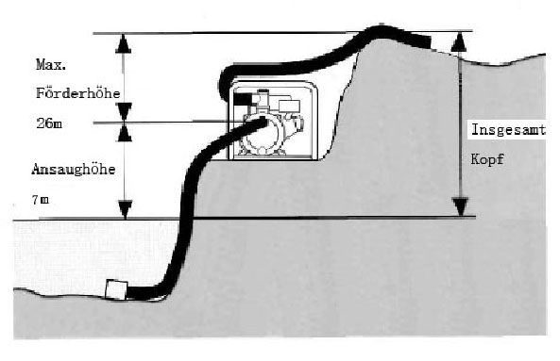Measuring point

Total height

Suction Height 7m

Height max.30m(HY50）

max.28m(HY80)

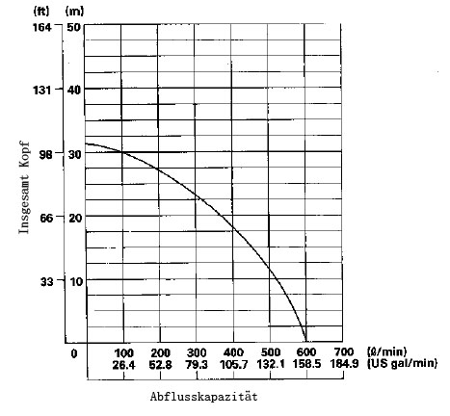

Declaration of conformity

HYUNDAI

ZI, 32 rue aristide Bergès - 31270 Cugnaux - France

Declares that the machine designated below:

THERMAL WATER PUMP

Ref: HY50-A

Serial number: 20190606739-20190606888

Complies with the provisions of the Machine Directive 2006/42 / EC and the national regulations transposing it;

Also complies with the provisions of the following European Directives:

To the EMC Directive 2014/30 / EU

Directive on noise emission in the environment of equipment intended for use outside buildings 2000/14 / EC & 2005/88 / EC

Also complies with European standards, national standards and the following technical provisions:

• EN 809: 1998 / A1: 2009; EN ISO 12100: 2010

• EN ISO 3744: 1995

• EN 55012: 2007 / A1: 2009

EN 61000-6-1:2007

Done at Cugnaux on 12/04/2019

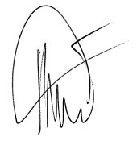

Philippe MARIE / PDG

